**Stage 4 - “Candy is dandy, but liquor is quicker”**

**COURSE DESIGNER:** John Royer / Outdoor Dynamics

|  |
| --- |
| **SCORING:** Comstock 21 rounds.  **TARGETS:** 10 cardboard targets, 1 steel target.  **SCORED HITS:** 2 Best hits per carboard will be scored. Steel must fall to score. |

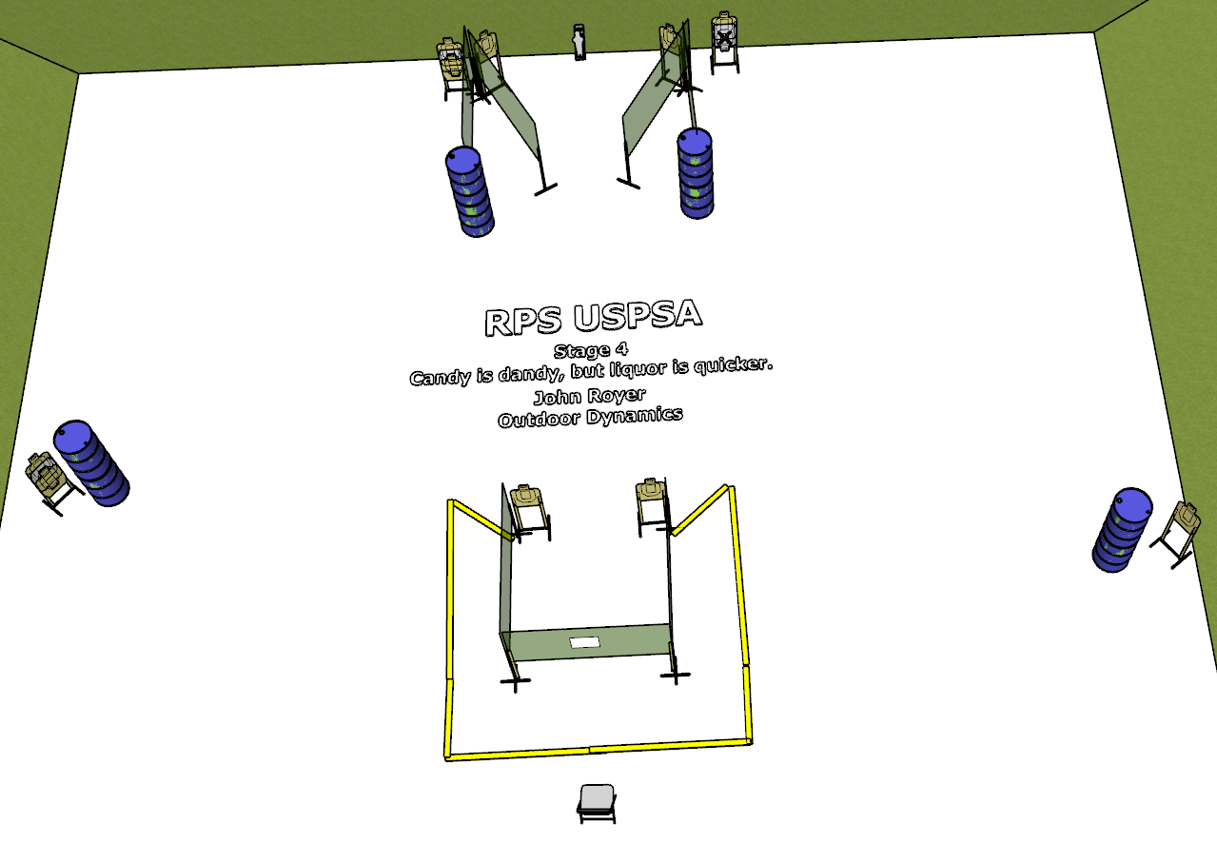

**Written Stage Briefing:**

**Stage 4 - “Candy is dandy, but liquor is quicker” -** is a 21-round, 105 point, Comstock Medium Course. There are 10 cardboard targets and one steel target. The best 2 hits per cardboard target will be scored. The steel must fall to score.

**Start position** Sitting in chair

**Handgun: loaded** and holstered

**PCC: loaded**, stock touching belt

On the audible start signal, engage targets from within the shooting area.

**USPSA / NROI Range Commands:**

* Make Ready
* Are you ready?
* Standby
* If finished, unload and show clear.
* If clear, hammer down and holster
* Range is clear

**Setup Notes:**

6 Single Wall Stands

4 Double Wall Stands

6 Full Walls

1 Port Walls

10 Target stands / 20 target sticks

1 Mini-Popper and base

8+ barrels

